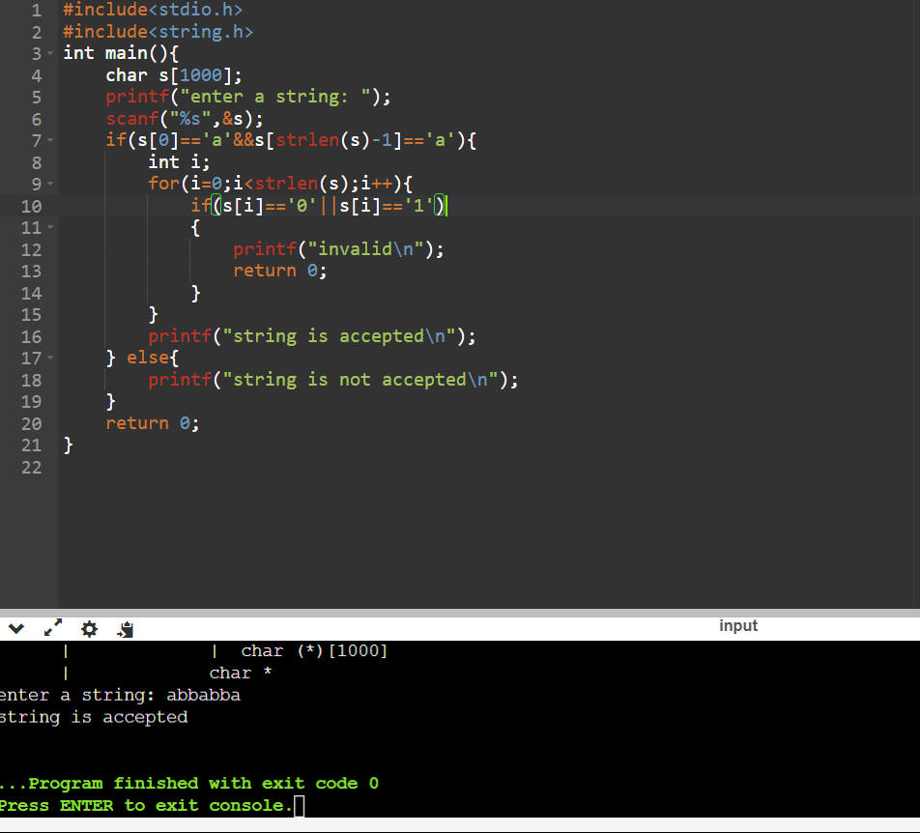1) DFA) for the given language representing strings that start with a and end with a.

2) (DFA) for the given language representing strings that start with 0 and end with 1

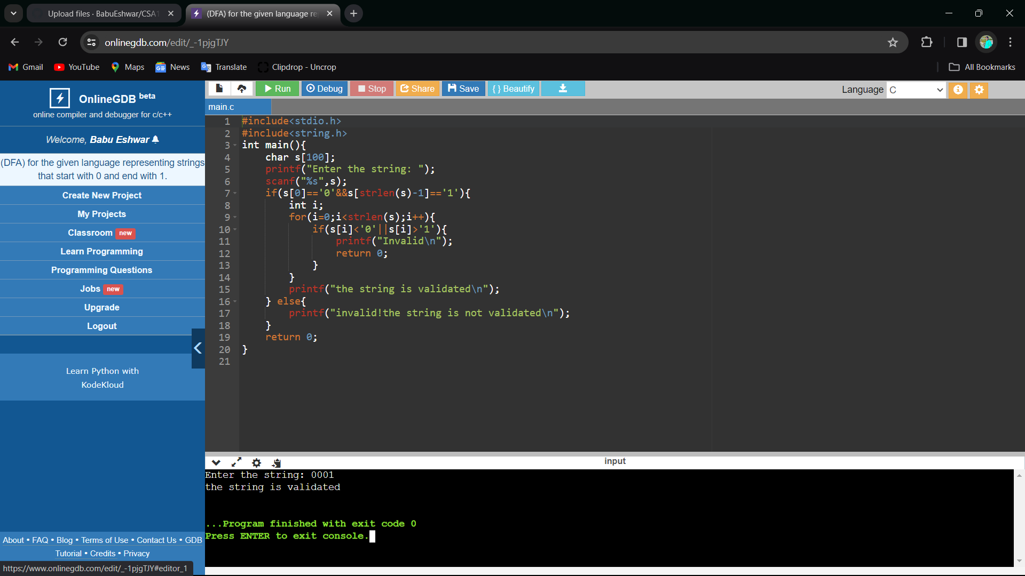

3) Grammar (CFG) S → 0A1 A → 0A | 1A | ε

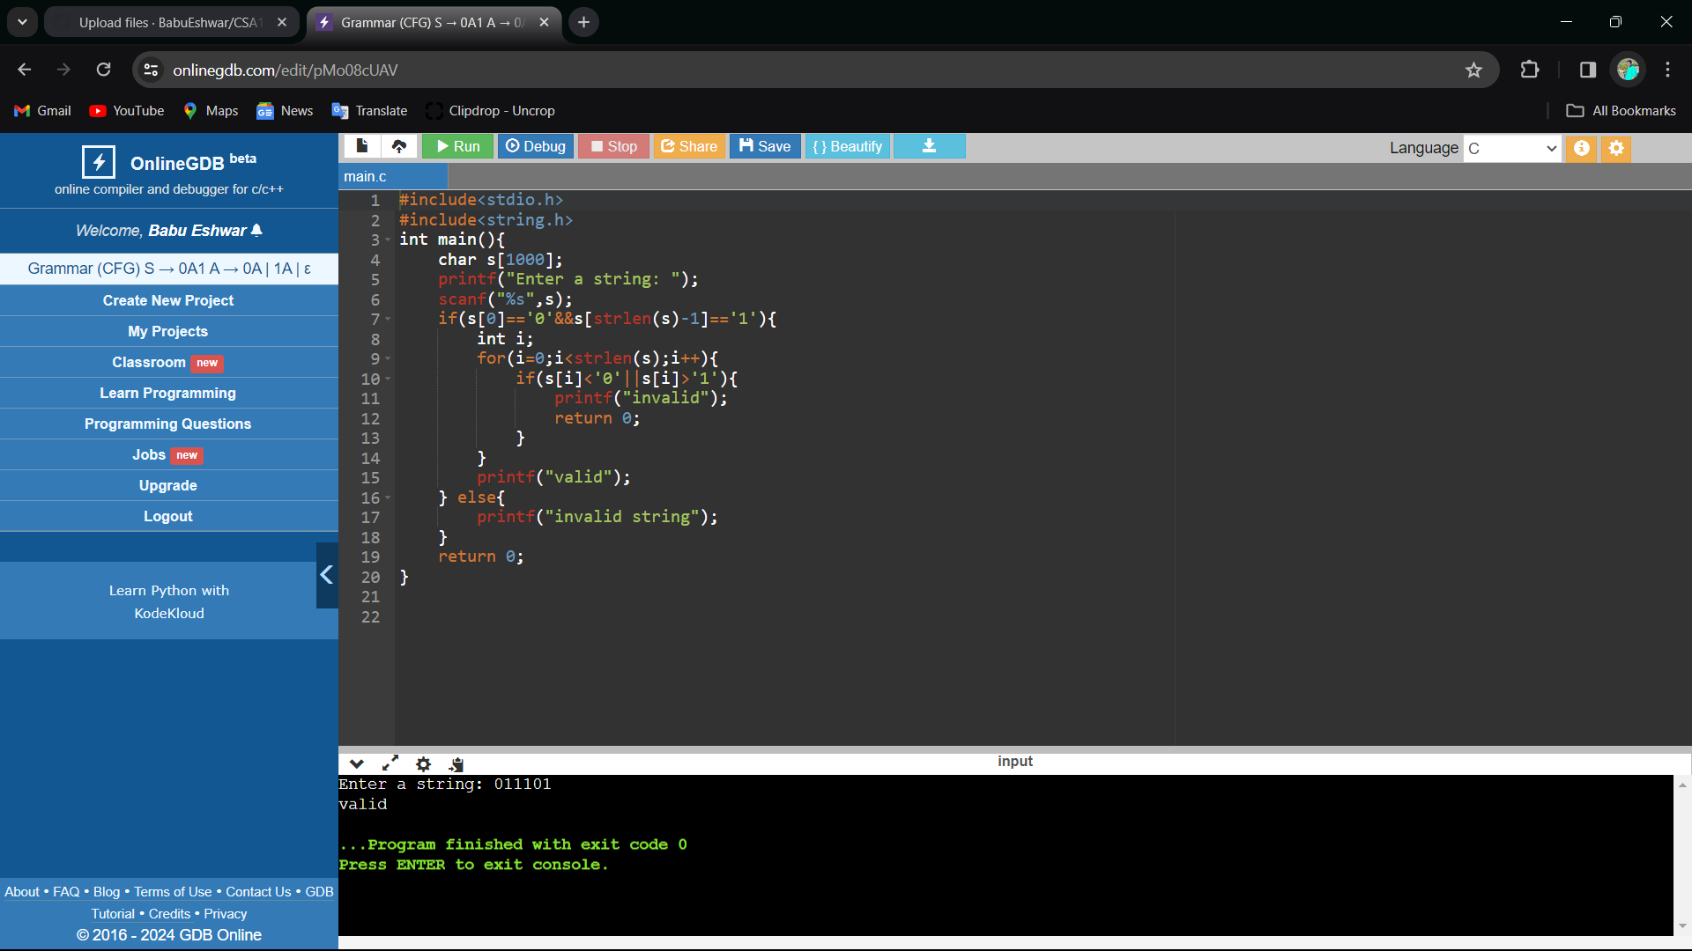

4) C program to check whether a given string belongs to the language defined by a Context Free Grammar (CFG) S → 0S0 | 1S1 | 0 | 1 | ε

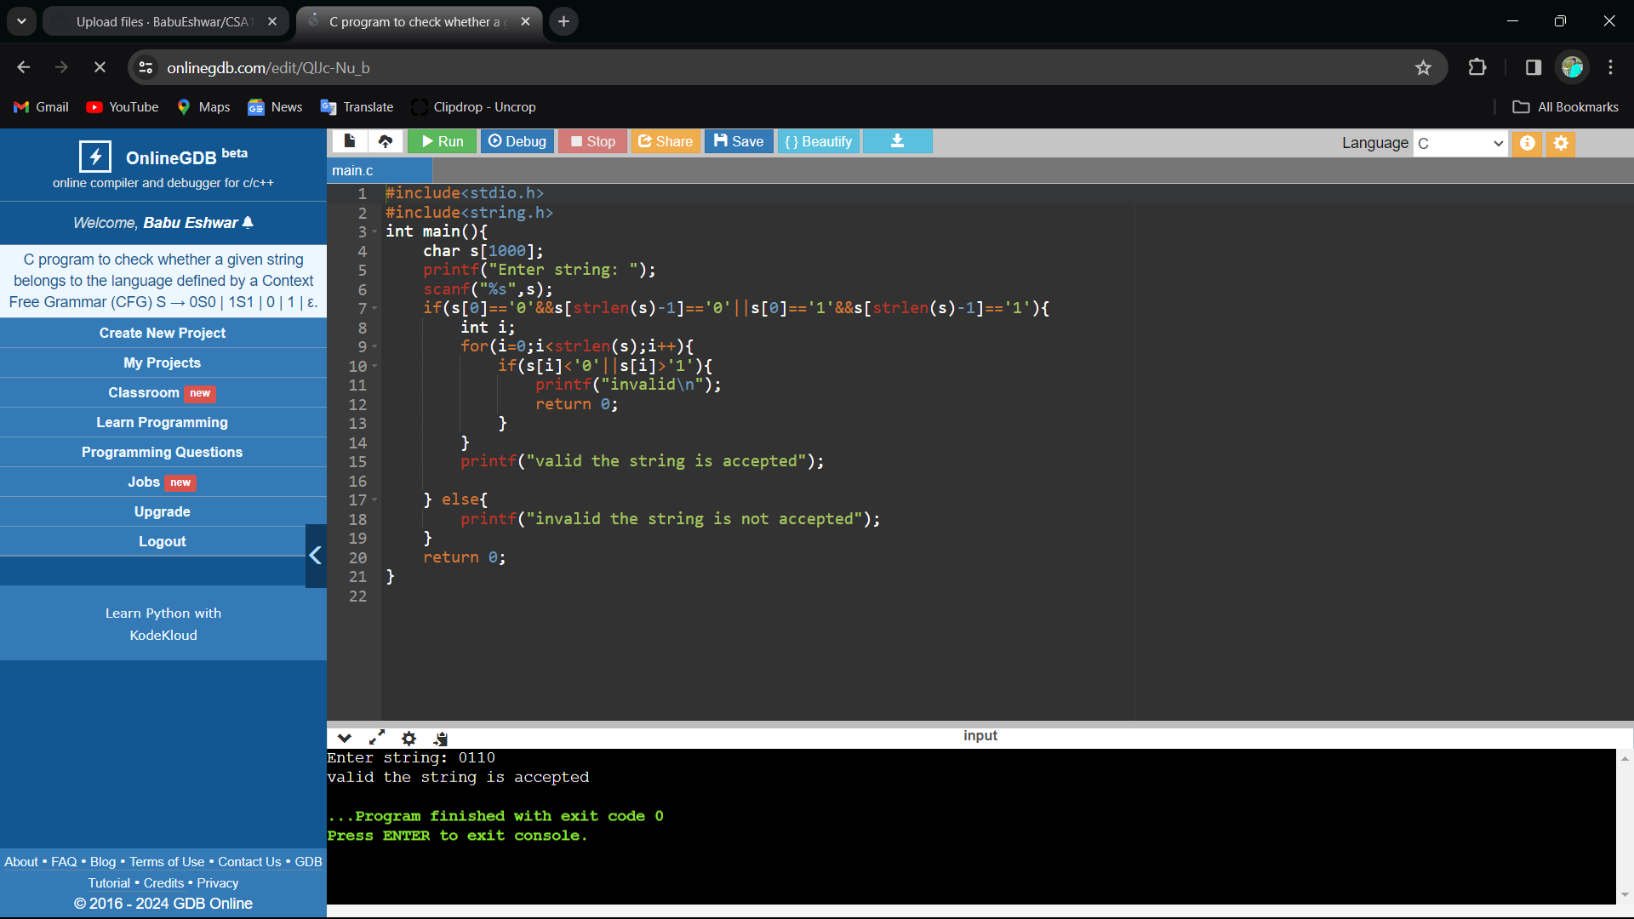

5) CFG s->0S0|A ,A->1A|E

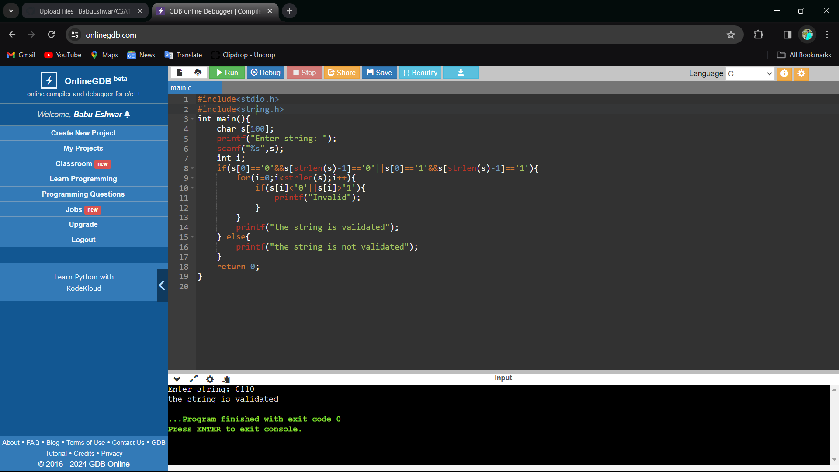

6) C program to check whether a given string belongs to the language defined by a Context Free Grammar (CFG) S → 0S1 | ε

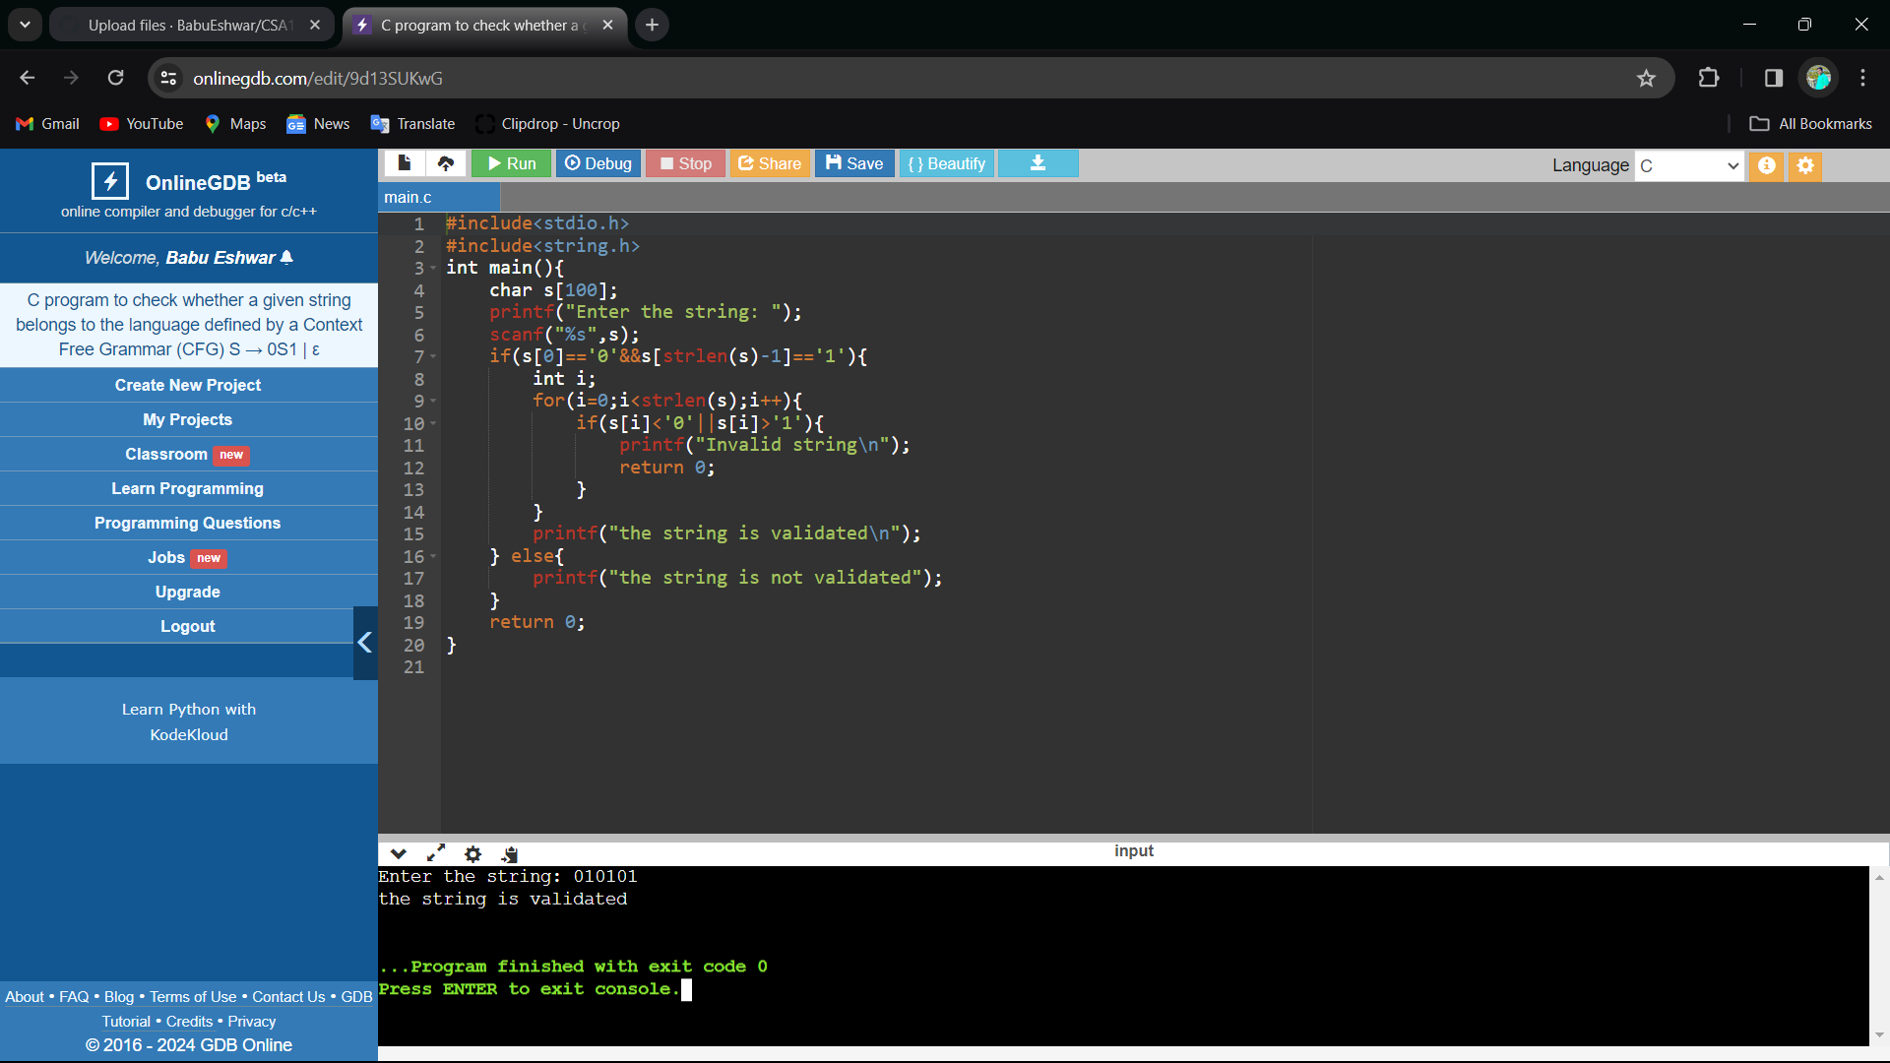

7) C program to check whether a given string belongs to the language defined by a Context Free Grammar (CFG) S → A101A, A → 0A | 1A | ε

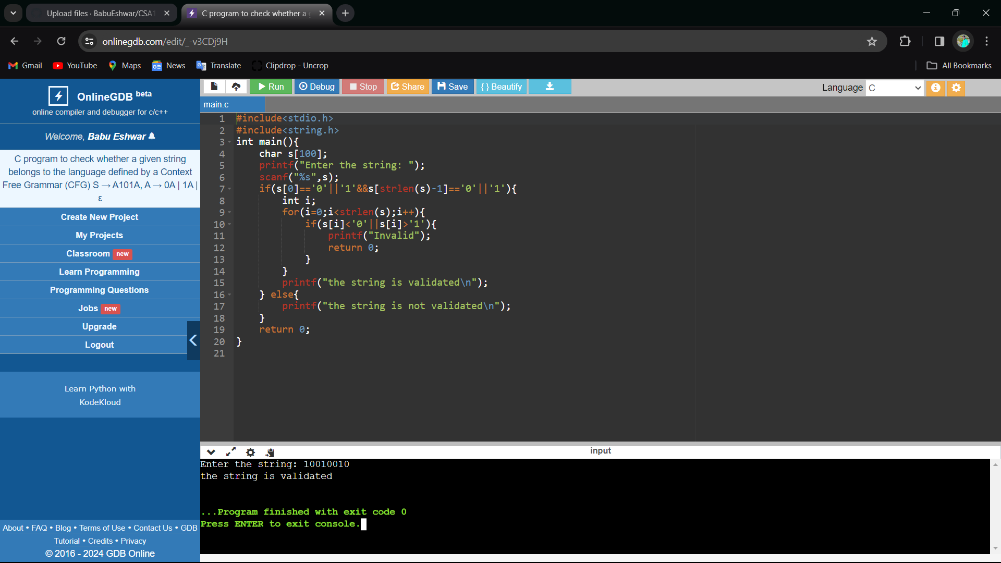

8) C program to simulate a Non-Deterministic Finite Automata (NFA) for the given language representing strings that start with b and end with a.

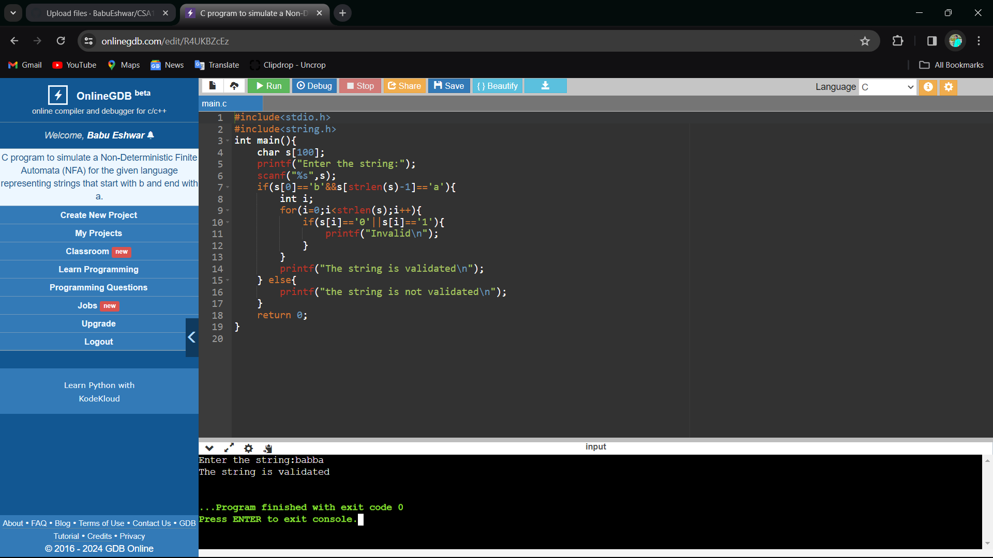

9) C program to simulate a Non-Deterministic Finite Automata (NFA) for the given language representing strings that start with o and end with 1

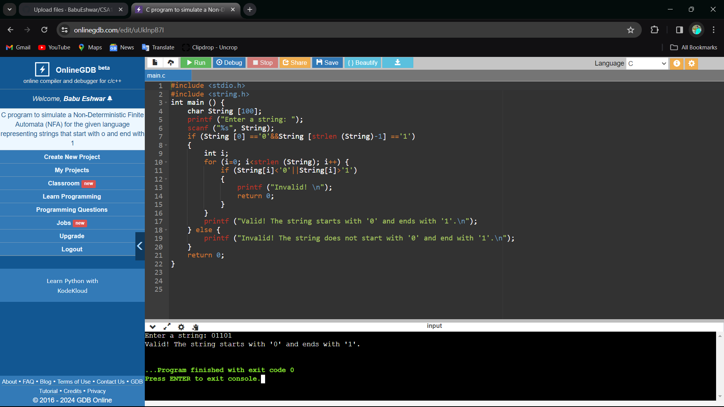

10) Write a C program to find ε -closure for all the states in a Non-Deterministic Finite Automata (NFA) with ε -moves

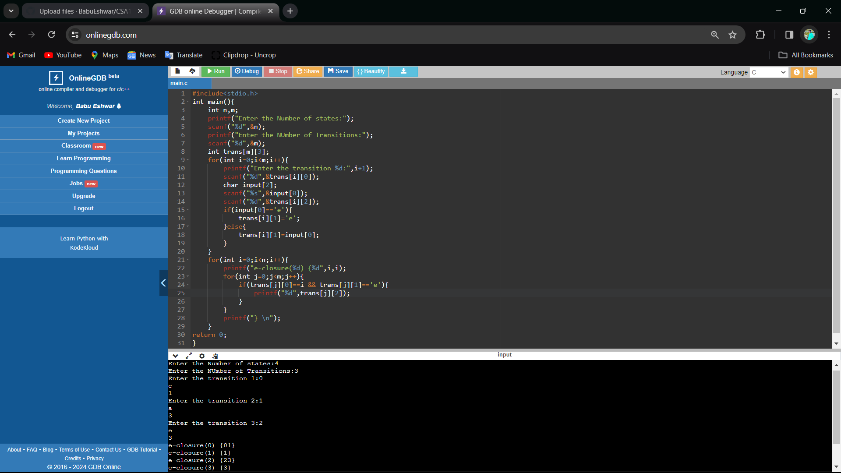

11) Write a C program to find ε -closure for all the states in a Non-Deterministic Finite Automata (NFA) with ε -moves